**2017-2018 East Baton Rouge Parish Schools Wellness Program**

PLEASE USE YOUR EMPLOYEE NUMBER AS YOUR USERNAME

East Baton Rouge Parish Schools value each of you and encourages you to be part of and participate in our 1st annual wellness program. You must be currently enrolled in the EBRPSS Self-Funded BCBSLA health plans in order to participate. You will find instructions below for completing your Personal Health Assessment (PHA)**.**

**INSTRUCTIONS TO LOG ACTIVITIES AND COMPLETE PHA**

**First Time Users:**

Log on to [www.bluewellnessla.com](http://www.bluewellnessla.com) and click “Register New Account”. Create username and password. Enter location code **77749FF4**

**Log on to** [**www.bluewellnessla.com**](http://www.bluewellnessla.com)

**Already Registered:**

Enter your username and password and click “GO”

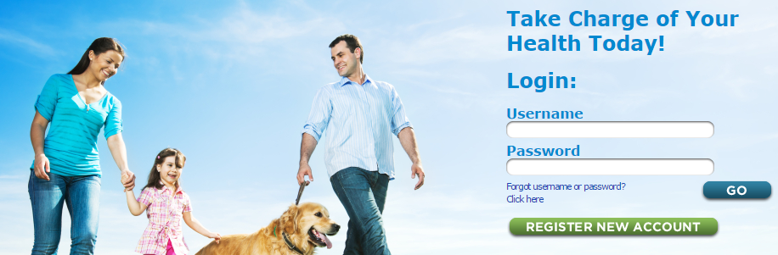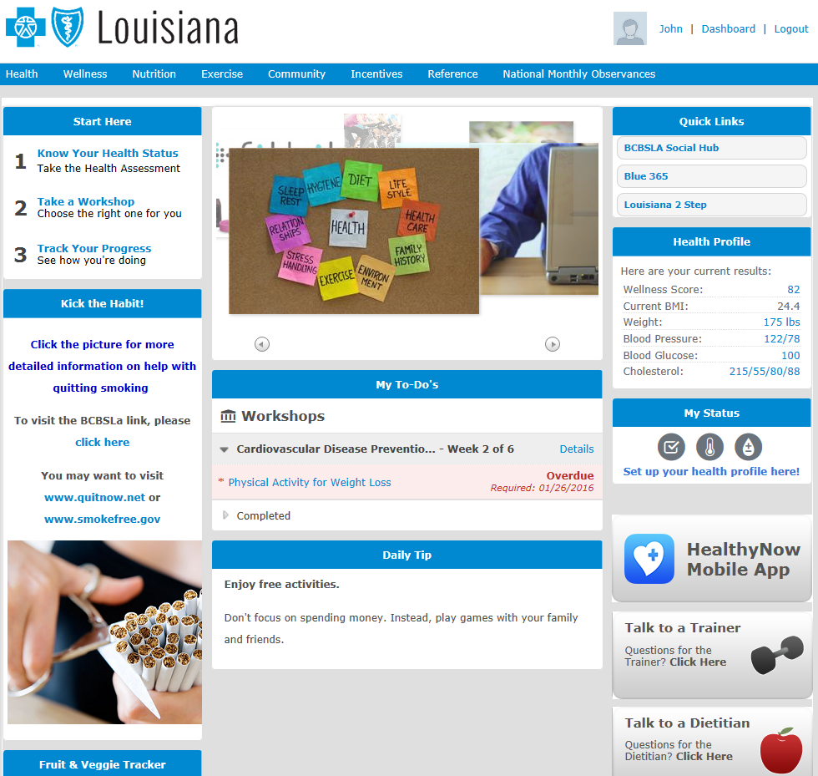

To track completed activities:

Click “Incentives” tab then click “Incentive Summary”.

**To log all other activities:**

Click “Incentives” tab then click “Healthy Habit” tab. Click “Complete” and give activity name and date of activity. Click “Update” then verify information to be accurate by clicking “OK”.

**To take a PHA:**

Click “1 – Know Your Health Status”